Microsoft Word Formatting Instructions for Modeling and World’s Systems 2019

Norman Borlaug¹, Dorothy Hodgkin², and Claude Shannon³
¹Department of Agronomy, Texas A&M University
²Department of Philosophy, Somerville College, Oxford
³Bell Labs, New Jersey

Abstract
Please keep your abstract short, fifteen lines or less. Remember that the MWS conference is attended by people from many academic disciplines, as well as colleagues in government, industry, foundations and nonprofits, and the defense and intelligence communities. So strive to make your abstract accessible.
- General Instructions
Papers should be no longer than seven pages, including the title, figures, references, etc. Seven pages isn’t a lot but attention spans are declining in our modern age and so, sadly, writing more won’t necessarily communicate more.
The style for Modeling the World’s Systems is simple and open. We eschew the two-column formats that are popular with some editors because they make for teenie-tiny figures, unless you let the figures stretch across columns, which is fiddly and often looks ugly. Actually, we’re pretty chill about layout, provided you maintain one-inch margins, leave a line between paragraphs, and don’t indent paragraphs (all of which are enforced by the current template).
Please use the standard indented form for quotations. You can cite with a standard reference, like this:
“Tomorrow,” said Toad. “There is dust on your chairs.”
“Tomorrow,” said Toad. “Your windows need scrubbing,” said Frog. “Your plants need watering.”
“Tomorrow!” cried Toad. “I will do it all tomorrow!” [1]
- Page Numbers
Please don’t have page numbers appear in your final draft. We’ll produce a technical report from accepted papers and we’ll want the pagination to be continuous.

Significance Please include one paragraph in your introductory section labeled “Significance,” in which you say how your work advances our ability to model complicated, interacting systems so as to provide actionable insights for policy and management.

- Figures
Please center your figures and don’t let them exceed the 1” margins.
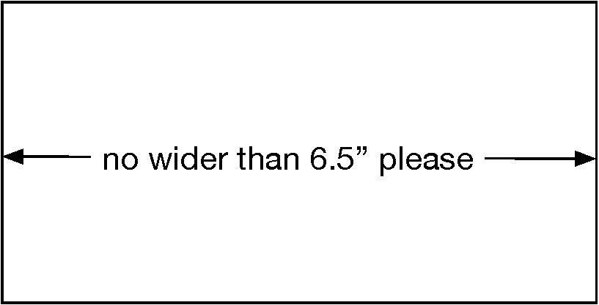
Figure 1: This is centered and 3” but you can have figured as wide as 6.5”
Subsections
Use standard numeric form for headers of sections, subsections, etc. This paragraph is a subsection of Section 3.
Itemized or enumerated lists are also allowed:
Rule 1: Thou shalt use itemized lists sparingly; and
Rule 2: Thou shalt remember Rule 1.
Note the closeup command in the latex file. It reduces the space between items.
3.1.1 Subsubsections and numbered paragraphs and…
Subsections and finer divisions are not encouraged (you only have seven pages!) but if you need them, go ahead.
- Acknowledgments
Please acknowledge funding sources, collaborators other than authors, suppliers of software and other resources, and any other help you received.
- Resources, Web sites, etc.
MWS seeks to build a community and share resources, so feel free to have a section in your paper that points readers to web sites, github pages, etc.
Reference
[1] Arnold Lobel. Days with Frog and Toad. 1979.

